What Is Science?
Day 1 and 2
Points of View: Science
You will work to show what you’ve learned
about science from several different viewpoints.
1. Review the lesson pages from your Ohio Science Fusion Student Edition Pages 4-15.
2. Complete your assignment, and practice presenting your work. You could be asked to present your perspective to your class when you return school.

 | Examples Develop a multimedia presentation in which you describe life science, earth science, and physical science. Then, give three specific examples of something a scientist would study in each.
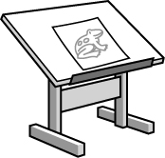 | Illustrations Draw a cartoon or comic strip of a scientist testing an idea of your choosing in either life science, earth science, or physical science. Be sure to include captions describing what your scientist is doing to test his or her ideas.
 | Analysis Suppose that you are a scientist reviewing an article that has been submitted to a respected science journal for publication. In the article, the author claims that a combination of a homeopathic drug and a conventional chemotherapeutic drug cures leukemia, a cancer of the blood. How will you decide whether to treat the investigation as science or pseudoscience? Write an interview that might take place between you and the author.
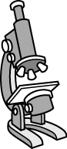 | Observations One of the characteristics of science is making detailed observations. Choose two items in your classroom (such as a piece of chalk or paper) and develop a list of 10 observations for each. You may use various tools in your classroom such as a microscope or ruler. Then, describe how you made the observations and recorded the results. You should include at least one description in words, numbers and units, and sketch or diagram for each item.
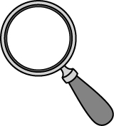 | Details Design a greeting card congratulating a scientist for using certain traits (curiosity, careful observation, logic, creativity, skepticism, and objectivity) when engaging in a scientific investigation. Be sure to identify how the scientist used each trait in your card.
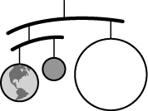 | Models Make a flow chart in which you describe how scientists develop and evaluate a scientific explanation, including when the data or other piece of evidence do or do not support the explanation.

